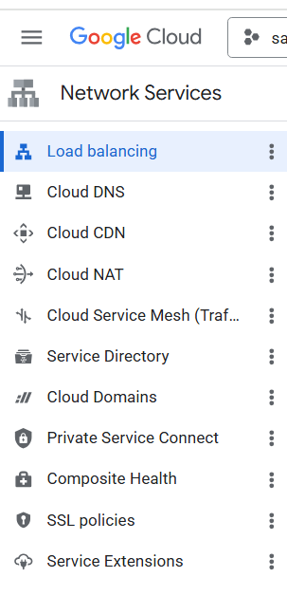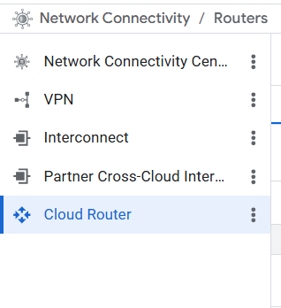

Cloud Load Balancing
A load balancer distributes user traffic across multiple instances of your applications. By spreading the load, load balancing reduces the risk that your applications experience performance issues. Google's Cloud Load Balancing is built on reliable, high-performing technologies such as Maglev, Andromeda, Google Front Ends, and Envoy—the same technologies that power Google's own products.
Cloud Load Balancing offers a comprehensive portfolio of application and network load balancers. Use our global proxy load balancers to distribute millions of requests per second among backends in multiple regions with our Google Front End fleet in over 80 distinct locations worldwide—all with a single, anycast IP address. Implement strong jurisdictional control with our regional proxy load balancers, keeping your backends and proxies in a region of your choice without worrying about TLS/SSL offload. Use our passthrough load balancers to quickly route multiple protocols to backends with the high performance of direct server return (DSR).
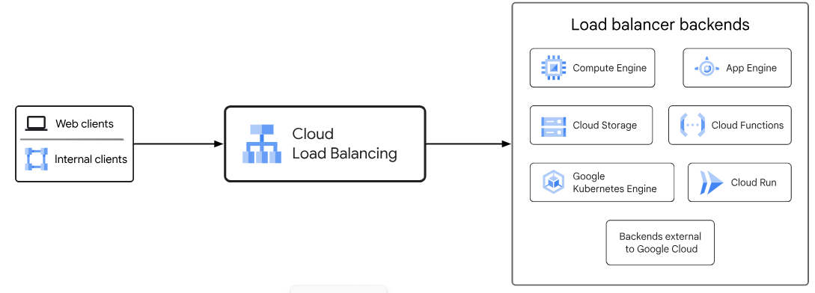

Key features of Cloud Load Balancing
Cloud Load Balancing offers the following load balancer features:
Single anycast IP address. With Cloud Load Balancing, a single anycast IP address is the frontend for all of your backend instances in regions around the world. It provides cross-region load balancing, including automatic multi-region failover, which moves traffic to failover backends if your primary backends become unhealthy. Cloud Load Balancing reacts instantaneously to changes in users, traffic, network, backend health, and other related conditions.
Seamless autoscaling. Cloud Load Balancing can scale as your users and traffic grow, including easily handling huge, unexpected, and instantaneous spikes by diverting traffic to other regions in the world that can take traffic. Autoscaling does not require pre-warming: you can scale from zero to full traffic in a matter of seconds.

Software-defined load balancing. Cloud Load Balancing is a fully distributed, software-defined, managed service for all your traffic. It is not an instance-based or device-based solution, so you won't be locked into a physical load-balancing infrastructure or face the high availability, scale, and management challenges inherent in instance-based load balancers.

Layer 4 and Layer 7 load balancing. Use Layer 4-based load balancing to direct traffic based on data from network and transport layer protocols such as TCP, UDP, ESP, GRE, ICMP, and ICMPv6 . Use Layer 7-based load balancing to add request routing decisions based on attributes, such as the HTTP header and the uniform resource identifier.
External and internal load balancing. Defines whether the load balancer can be used for external or internal access. You can use an external load balancer when your clients need to reach your application from the internet. You can use an internal load balancer when your clients are inside of Google Cloud.
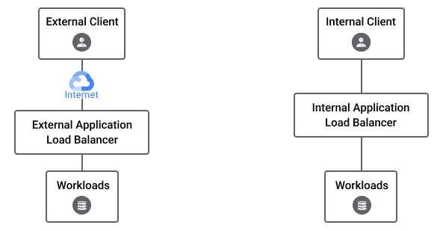

Global and regional load balancing. Defines the scope of the load balancer. A global load balancer supports backends in multiple regions, whereas a regional load balancer supports backends in a single region. Even though the IP address of a regional load balancer is located in one region, a regional load balancer is globally accessible. You can distribute your backends in single or multiple regions to terminate connections close to your users and to meet your high availability requirements.
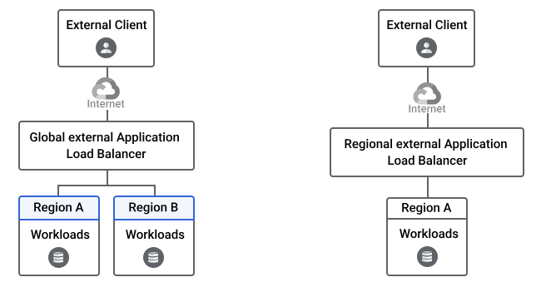
Routing of traffic in Premium Tier and Standard Tier. The load balancing services in Google Cloud come in different flavors depending on the network tier you choose, that is, Premium Tier or Standard Tier, with the former being more expensive than the latter. The Premium Tier leverages Google's high-quality global backbone whereas the Standard Tier uses the public internet to route traffic across the network. The network tier you choose depends on whether you prioritize cost or performance for your enterprise workload. Some load balancing services are only available in Premium Tier and not the Standard Tier. To learn more, see Premium versus Standard Network Service Tiers.
Advanced feature support. Cloud Load Balancing supports features such as IPv6 load balancing, source IP-based traffic steering, weighted load balancing, WebSockets, user-defined request headers, and protocol forwarding for private virtual IP addresses (VIPs).
It also includes the following integrations:
- Integration with Cloud CDN for cached content delivery. Cloud CDN is supported with the global external Application Load Balancer and the classic Application Load Balancer.
- Cloud CDN (Content Delivery Network) uses Google's global edge network to serve content closer to users, which accelerates your websites and applications.
- Cloud CDN works with the global external Application Load Balancer or the classic Application Load Balancer to deliver content to your users. The external Application Load Balancer provides the frontend IP addresses and ports that receive requests and the backends that respond to the requests.
- Cloud CDN content can be sourced from various types of backends. In Cloud CDN, these backends are also called origin servers.
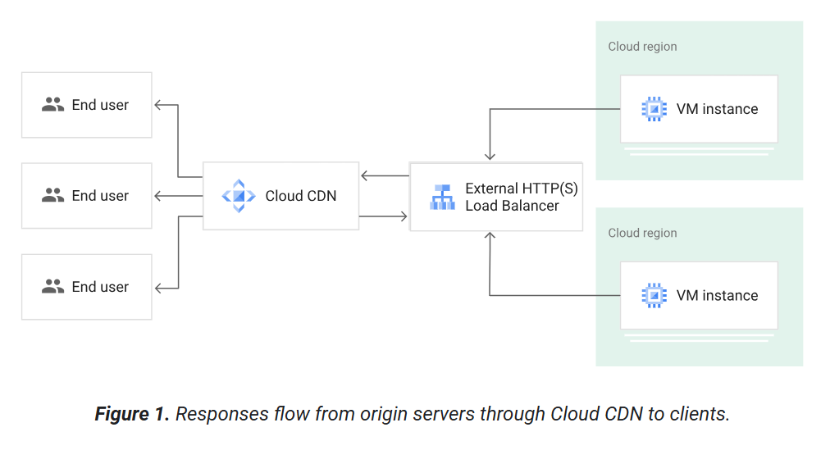
- Integration with Google Cloud Armor to protect your infrastructure from distributed denial-of-service (DDoS) attacks and other targeted application attacks. Google Cloud Armor is a network security service that provides defenses against DDoS and application attacks and offers a rich set of web application firewall (WAF) rules. Google Cloud Armor is a web application firewall (WAF) and DDoS defense service offered by Google Cloud Platform. Always-on DDoS protection is available for the global external Application Load Balancer, the classic Application Load Balancer, the external proxy Network Load Balancer, and the external passthrough Network Load Balancer. Additionally, Google Cloud Armor supports advanced network DDoS protection only for external passthrough Network Load Balancers.

Types of Google Cloud load balancers
Cloud Load Balancing offers two types of load balancers: Application Load Balancers and Network Load Balancers. You'd choose an Application Load Balancer when you need a Layer 7 load balancer for your applications with HTTP(S) traffic. You'd choose a Network Load Balancer when you need a Layer 4 load balancer that supports TLS offloading (with a proxy load balancer) or you need support for IP protocols such as UDP, ESP, and ICMP (with a passthrough load balancer).
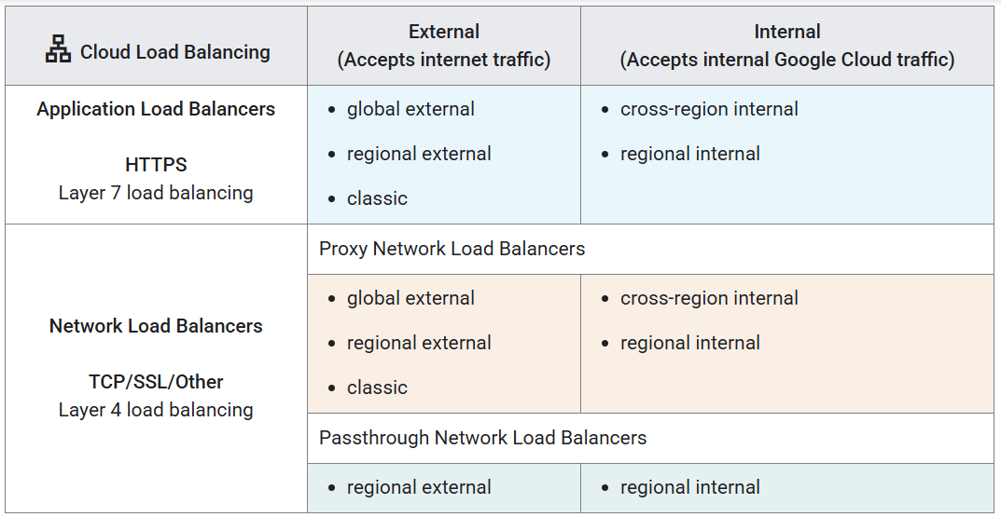

1) Application Load Balancer (HTTP/HTTPS) Layer: 7 (Application Layer)
Choose an Application Load Balancer when you need a flexible feature set for your applications with HTTP and HTTPS traffic. You'd choose an Application Load Balancer when you need a Layer 7 load balancer for your applications with HTTP(S) traffic. The Application Load Balancer distributes HTTP and HTTPS traffic to backends hosted on a variety of Google Cloud platforms—such as Compute Engine, Google Kubernetes Engine (GKE), Cloud Storage, and Cloud Run—as well as external backends connected over the internet or by using hybrid connectivity. Application Load Balancers use the open source Envoy proxy to enable advanced traffic management capabilities.
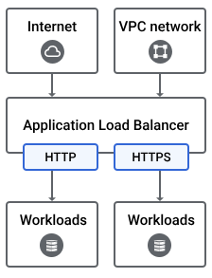
Use case: When you need advanced routing based on application-level content.
Features:
- Supports content-based routing (e.g., route based on URL path, hostname, HTTP headers, HTTP methods).
- Handles HTTP and HTTPS traffic.
- Can do host-based or path-based routing.
- Supports WebSocket and HTTP/2.
- Provides detailed health checks (e.g., HTTP status codes).
- Can integrate with authentication, WAF (Web Application Firewall), and SSL termination.
When to choose:
- Your app needs smart routing decisions based on HTTP(s) requests.
- You want to load balance web traffic (APIs, websites, microservices).
- You want SSL termination at the load balancer.
- You need detailed monitoring on application metrics.
Application Load Balancers are available in the following modes of deployment:
1) External Application Load Balancer: Load balances traffic coming from clients on the internet. External Application Load Balancers are implemented as managed services either on Google Front Ends (GFEs) or Envoy proxies. Clients can connect to these load balancers from anywhere on the internet. External Application Load Balancers using target HTTPS proxies require private keys and SSL certificates as part of the load balancer configuration.
External Application Load Balancers support the following capabilities:
Advanced traffic management such as traffic mirroring, weight-based traffic splitting, and request/response-based header transformations.
Load balancing traffic to backends hosted on a variety of Google Cloud platforms such as Compute Engine, Google Kubernetes Engine (GKE), Cloud Run, and more. Backend support depends on the deployment mode of the load balancer
Cached responses with Cloud CDN.
Protection from DDoS or other web attacks by using Google Cloud Armor.
Load balancing to GKE by using either Ingress or Gateway (fully orchestrated) or standalone NEGs.
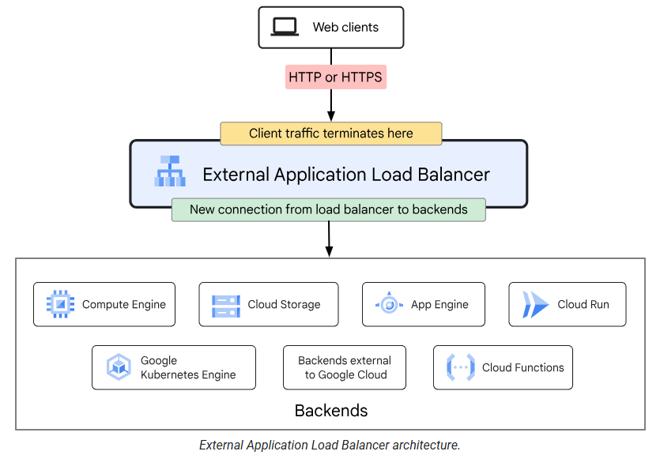
Types of External Application Load Balancer:
- Global external Application Load Balancer. This is a global load balancer that is implemented as a managed service on Google Front Ends (GFEs). It uses the open-source Envoy proxy to support advanced traffic management capabilities such as traffic mirroring, weight-based traffic splitting, and request-based or response-based header transformations. Global external Application Load Balancers support backends in multiple regions. Use this load balancer for external HTTP(S) workloads with globally dispersed users or backend services in multiple regions. It uses a global IP address to route traffic to the closest healthy backend across multiple regions, based on latency and availability. It supports SSL termination, content-based routing, and autoscaling through MIGs.
- Regional external Application Load Balancer. This is a regional load balancer that is implemented as a managed service on the open-source Envoy proxy. It includes advanced traffic management capabilities such as traffic mirroring, weight-based traffic splitting, and request-based or response-based header transformations. Regional external Application Load Balancers support backends in a single region only. This load balancer contains many of the features of the existing classic Application Load Balancer, along with advanced traffic management capabilities. Use this load balancer if you want to serve content from only one geolocation
- Classic Application Load Balancer. This is the classic external Application Load Balancer that is global in Premium Tier but can be configured to be regional in Standard Tier. This load balancer is implemented on Google Front Ends (GFEs). GFEs are distributed globally and operate together using Google's global network and control plane. Classic Application Load Balancers are global in Premium Tier. In Standard Tier, they can distribute traffic to backends in a single region only.
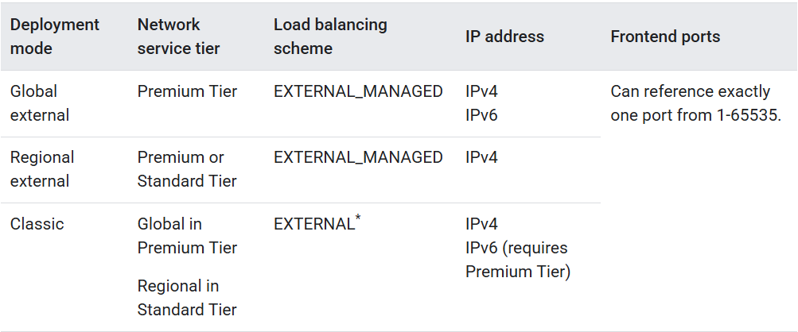
2) Internal Application Load Balancer: Load balances traffic within your VPC network or networks connected to your VPC network. This load balancer provides internal proxy-based load balancing of Layer 7 application data. The load balancer uses an internal IP address that is accessible only to clients in the same VPC network or clients connected to your VPC network. The internal Application Load Balancer distributes HTTP and HTTPS traffic to backends hosted on a variety of Google Cloud platforms such as Compute Engine, Google Kubernetes Engine (GKE), and Cloud Run. You can enable global access for Regional internal Application Load Balancer to make them accessible to clients in all regions.
Internal Application Load Balancers also support the following features:
Locality policies. Within a backend instance group or network endpoint group, you can configure how requests are distributed to member instances or endpoints.
Global access. When global access is enabled, clients from any region can access the load balancer.
Access from connected networks. You can make your load balancer accessible to clients from networks beyond its own Google Cloud Virtual Private Cloud (VPC) network. The other networks must be connected to the load balancer's VPC network by using either VPC Network Peering, Cloud VPN, or Cloud Interconnect.
Compatibility with GKE by using Ingress (fully orchestrated).
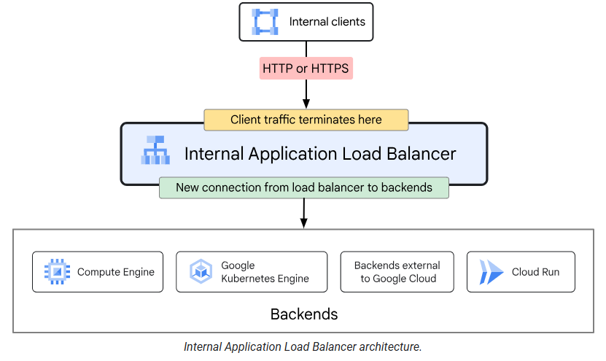
Types of Internal Application Load Balancer:
- Regional internal Application Load Balancers: Regional internal Application Load Balancers support backends only in a single region. Load balancer can only send traffic to backends that are in the same region as the proxy of the load balancer. Automatic failover to healthy backends in the same region. This load balancer is enabled with rich traffic control capabilities based on HTTP or HTTPS parameters. After the load balancer is configured, it automatically allocates Envoy proxies to meet your traffic needs. Not globally accessible by default. You can optionally enable global access.
- Cross-region internal Application Load Balancer: Cross-region internal Application Load Balancers support backends in multiple regions and are always globally accessible. Clients from any Google Cloud region can send traffic to the load balancer. This load balancer also enables high availability. Placing backends in multiple regions helps avoid failures in a single region. If one region's backends are down, traffic can fail over to another region. Automatic failover to healthy backends in the same or different regions.
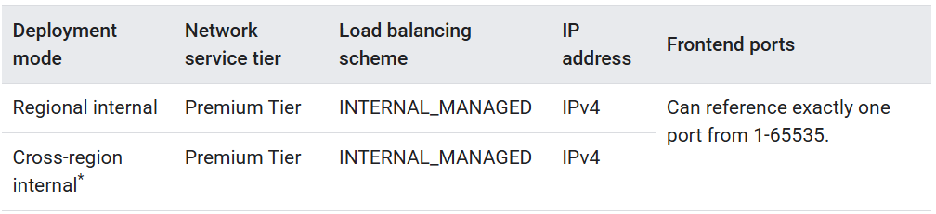
2) Network Load Balancer (TCP/UDP/TLS or SSL) Layer: 4 (Transport Layer)
Choose a Network Load Balancer when you need TLS offloading at scale, support for UDP, and exposing IP addresses to your applications. Network Load Balancers are Layer 4 load balancers that can handle TCP, UDP, or other IP protocol traffic. These load balancers are available as either proxy load balancers or passthrough load balancers. You can pick a load balancer depending on the needs of your application and the type of traffic that it needs to handle. Choose a proxy Network Load Balancer if you want to configure a reverse proxy load balancer with support for advanced traffic controls and backends on-premises and in other cloud environments. Choose a passthrough Network Load Balancer if you want to preserve the source IP address of the client packets, you prefer direct server return for responses, or you want to handle a variety of IP protocols such as TCP, UDP, ESP, GRE, ICMP, and ICMPv6
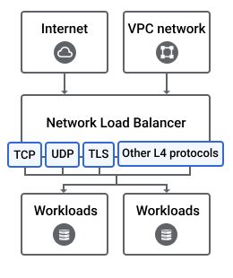
Use case: When you want ultra-high performance, low latency, and TCP/UDP level routing.
Features:
- Handles TCP, UDP, and TLS traffic.
- Capable of handling millions of requests per second with very low latency.
- Passes through the client’s IP address to the backend (important for logging/security).
- Provides static IP addresses and supports Elastic IPs.
- Does not inspect or modify application data.
- Health checks are TCP/UDP based.
When to choose:
- Your application requires extremely high throughput and low latency (e.g., gaming, IoT, real-time communication).
- You need to load balance non-HTTP(S) traffic.
- You need to preserve the source IP address of clients.
- You want static IP addresses for your load balancer.
Types of Network Load Balancers:
Proxy Network Load Balancer: Proxy Network Load Balancers are layer 4 reverse proxy load balancers that distribute TCP traffic to backends in your Google Cloud Virtual Private Cloud (VPC) network or in other cloud environments. Traffic is terminated at the load balancing layer and then forwarded to the closest available backend by using TCP. Choose a proxy Network Load Balancer to implement TCP proxy load balancing to backends in one or more regions. Proxy-based load balancing of TCP traffic with advanced traffic control including support for hybrid backends on-prem and other clouds.
The proxy Network Load Balancers support the following features:
TLS/SSL offload for external load balancers. You can use a global external proxy Network Load Balancer or a classic proxy Network Load Balancer to offload TLS at the load balancing layer by using an SSL proxy.
Support for all ports. These load balancers allow any valid port from 1-65535.
Port remapping. The port used by the load balancer's forwarding rule does not have to match the port used when making connections to its backends. For example, the forwarding rule could use TCP port 80, while the connection to the backends could use TCP port 8080.
Relays original source IP address. You can use the PROXY protocol to relay the client's source IP address and port information to the load balancer backends.
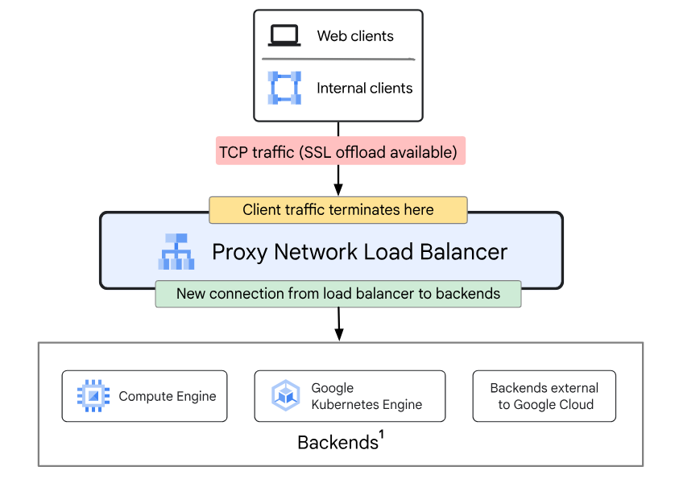
Proxy Network Load Balancers are available in the following modes of deployment:
1) External proxy Network Load Balancer: Load balances traffic that comes from clients on the internet. The external proxy Network Load Balancer is a reverse proxy load balancer that distributes TCP traffic coming from the internet to backends in your Google Cloud Virtual Private Cloud (VPC) network. When using an external proxy Network Load Balancer, incoming TCP or SSL traffic is terminated at the load balancer. A new connection then forwards traffic to the closest available backend by using either TCP or SSL (recommended). External proxy Network Load Balancers let you use a single IP address for all users worldwide. The load balancer automatically routes traffic to the backends that are closest to the user.
External proxy Network Load Balancers support the following features:
IPv6 termination. The external load balancers support both IPv4 and IPv6 addresses for client traffic. Client IPv6 requests are terminated at the load balancing layer and then proxied over IPv4 to your backends.
TLS/SSL offload. You can use a global external proxy Network Load Balancer or a classic proxy Network Load Balancer to offload TLS at the load balancing layer by using an SSL proxy. New connections are forwarded to the closest available backends by using either SSL (recommended) or TCP. You can configure the following aspects of your deployment:
- Better utilization of backends. SSL processing can be very CPU-intensive if the ciphers used are not CPU efficient. To maximize CPU performance, use ECDSA SSL certificates and TLS 1.2, and prefer the ECDHE-ECDSA-AES128-GCM-SHA256 cipher suite for SSL between the load balancer and your backend instances.
- SSL policies. SSL policies give you the ability to control the features of SSL that your load balancer negotiates with clients.
Integration with Cloud Armor. You can use Cloud Armor security policies to protect your infrastructure from distributed denial-of-service (DDoS) attacks and other targeted attacks.
Geographic control over where TLS is terminated. The load balancer terminates TLS in locations that are distributed globally, so as to minimize latency between clients and the load balancer. If you require geographic control over where TLS is terminated, you can use the Standard Network Tier to force the load balancer to terminate TLS on backends that are located in a specific region only. For details, see Configuring Standard Tier.
Support for App Hub. Resources used by regional external proxy Network Load Balancers can be designated as services in App Hub applications.
You can configure an external proxy Network Load Balancer in the following modes:
- Global external proxy Network Load Balancers: Global external proxy Network Load Balancers support backends in multiple regions. A global external proxy Network Load Balancer is implemented on globally distributed GFEs and supports advanced traffic management capabilities. This load balancer can be configured to handle either TCP or SSL traffic by using either a target TCP proxy or a target SSL proxy respectively. This load balancer is configured as a global load balancing service with the Premium Tier. Global external proxy Network Load Balancers can also be used for other protocols that use SSL, such as WebSockets and IMAP over SSL.
- Regional external proxy Network Load Balancers: Regional external proxy Network Load Balancers support backends in a single region. A regional external proxy Network Load Balancer is implemented on the open-source Envoy proxy software stack. It can handle only TCP traffic. This load balancer is configured as a regional load balancing service that can use either Premium or Standard Tier. You can enable global access for Regional internal proxy Network Load Balancer to make them accessible to clients in all regions.
- Classic proxy Network Load Balancers: Classic proxy Network Load Balancers are global in Premium Tier. In Standard Tier, they can distribute traffic to backends in a single region only. A classic proxy Network Load Balancer is implemented on globally distributed Google Front Ends (GFEs). This load balancer can be configured to handle either TCP or SSL traffic by using either a target TCP proxy or a target SSL proxy respectively. With the Premium Tier, this load balancer can be configured as a global load balancing service. With Standard Tier, this load balancer is configured as a regional load balancing service. Classic proxy Network Load Balancers can also be used for other protocols that use SSL, such as WebSockets and IMAP over SSL.
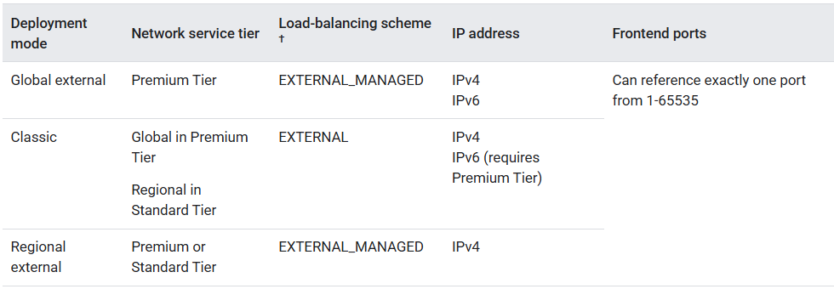
2) Internal proxy Network Load Balancer: Load balances traffic within your VPC network or networks connected to your VPC network. Internal proxy Network Load Balancers are Envoy proxy-based regional Layer 4 load balancers that enable you to run and scale your TCP service traffic behind an internal IP address that is accessible only to clients in the same VPC network or clients connected to your VPC network. The load balancer first terminates the TCP connection between the client and the load balancer at an Envoy proxy. The proxy opens a second TCP connection to backends hosted in Google Cloud, on-premises, or other cloud environments.
Internal proxy Network Load Balancers support the following features:
Locality policies. Within a backend instance group or network endpoint group, you can configure how requests are distributed to member instances or endpoints.
Global access. When global access is enabled, clients from any region can access the load balancer.
Access from connected networks. You can make your internal load balancer accessible to clients from networks beyond its own Google Cloud VPC network. The other networks must be connected to the load balancer's VPC network by using either VPC Network Peering, Cloud VPN, or Cloud Interconnect.
Support for App Hub. Resources used by regional internal proxy Network Load Balancers can be designated as services in App Hub applications.
You can configure an internal proxy Network Load Balancer in the following modes:
- Regional internal proxy Network Load Balancer: Regional internal proxy Network Load Balancers support backends in a single region only. This is a regional load balancer that is implemented as a managed service based on the open-source Envoy proxy. With regional mode, all clients and backends are from a specified region, which helps when you need regional compliance.
- Cross-region internal proxy Network Load Balancers: Cross-region internal proxy Network Load Balancers support backends in multiple regions and are always globally accessible. Clients from any Google Cloud region can send traffic to the load balancer. You can set up a cross-region internal proxy Network Load Balancer in multiple regions to get the following benefits:
1. If backends in a particular region are down, the traffic fails over to the backends in another region gracefully.
2. Cross-region internal proxy Network Load Balancers can also shield your application from complete regional outages by serving traffic to your client from proxies and backends in another region.
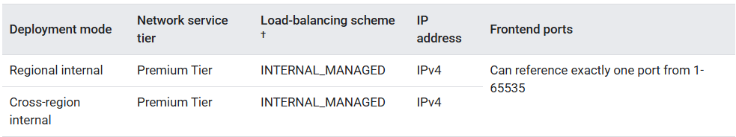
Passthrough Network Load Balancers: Passthrough Network Load Balancers are Layer 4 regional, passthrough load balancers. These load balancers distribute traffic among backends in the same region as the load balancer. As the name suggests, passthrough Network Load Balancers are not proxies. Load-balanced packets are received by backend VMs with the packet's source and destination IP addresses, protocol, and, if the protocol is port-based, the source and destination ports unchanged. Load-balanced connections are terminated at the backends. Responses from the backend VMs go directly to the clients, not back through the load balancer. The industry term for this is direct server return (DSR). Choose a passthrough Network Load Balancer to preserve client source IP addresses, avoid the overhead of proxies, and to support additional protocols like UDP, ESP, and ICMP. Pass through load-balancers load balance TCP/UDP traffic without proxying the traffic to the backends. They preserve the source-ip address of the packet. They also support load-balancing of UDP, ICMP, SCTP, GRE traffic.
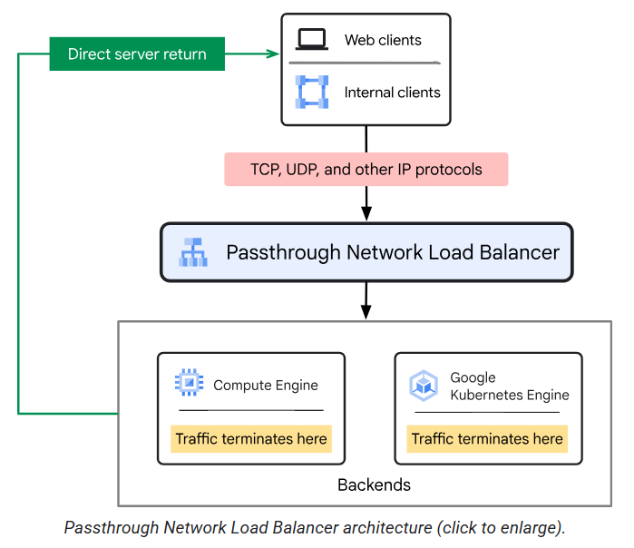

Passthrough Network Load Balancers are available in the following modes of deployment.
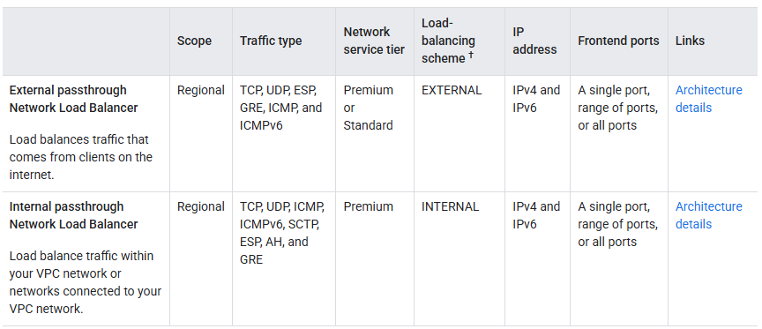
1) External passthrough Network Load Balancers: External passthrough Network Load Balancers are regional, Layer 4 load balancers that distribute external traffic among backends (instance groups or network endpoint groups (NEGs)) in the same region as the load balancer. These backends must be in the same region and project but can be in different VPC networks. These load balancers are built on Maglev and the Andromeda network virtualization stack. External passthrough Network Load Balancers distribute TCP and UDP traffic among backend virtual machine (VM) instances in the same region in a Virtual Private Cloud (VPC) network.
External passthrough Network Load Balancers can receive traffic from:
- Any client on the internet
- Google Cloud VMs with external Ips
- Google Cloud VMs that have internet access through Cloud NAT or instance-based NAT
External passthrough Network Load Balancers are not proxies. The load balancer itself doesn't terminate user connections. Load-balanced packets are sent to the backend VMs with their source and destination IP addresses, protocol, and, if applicable, ports, unchanged. The backend VMs then terminate user connections. Responses from the backend VMs go directly to the clients, not back through the load balancer. This process is known as direct server return (DSR).
You'd use a passthrough Network Load Balancer in the following circumstances:
- You need to forward original client packets to the backends un-proxied—for example, if you need the client source IP address to be preserved.
- You need to load balance TCP, UDP, ESP, GRE, ICMP, and ICMPv6 traffic, or you need to load balance a TCP port that isn't supported by other load balancers.
- It is acceptable to have SSL traffic decrypted by your backends instead of by the load balancer. The passthrough Network Load Balancer cannot perform this task. When the backends decrypt SSL traffic, there is a greater CPU burden on the VMs.
- You are able to manage the backend VM's SSL certificates yourself. Google-managed SSL certificates are only available for proxy load balancers.
- You have an existing setup that uses a passthrough load balancer, and you want to migrate it without changes.
Backends for external passthrough Network Load Balancers can be deployed using either a backend service or a target pool.
Backend service-based external passthrough Network Load Balancer: External passthrough Network Load Balancers can be created with a regional backend service that defines the behavior of the load balancer and how it distributes traffic to its backends. Backend service-based external passthrough Network Load Balancers support IPv4 and IPv6 traffic, multiple protocols ( TCP, UDP, ESP, GRE, ICMP, and ICMPv6 ), managed and unmanaged instance group backends, zonal network endpoint group (NEG) backends with GCE_VM_IP endpoints, fine-grained traffic distribution controls, failover policies, and let you use non-legacy health checks that match the type of traffic (TCP, SSL, HTTP, HTTPS, or HTTP/2) that you are distributing. Load balancing to Google Kubernetes Engine (GKE) is handled by using the built-in GKE Service controller. In addition, backend service-based external passthrough Network Load Balancers are supported with App Hub.
Backend service-based external passthrough Network Load Balancers support the following features:
- Managed and unmanaged instance group backends. Backend service-based external passthrough Network Load Balancers support both managed and unmanaged instance groups as backends. Managed instance groups automate certain aspects of backend management and provide better scalability and reliability as compared to unmanaged instance groups.
- Zonal NEG backends. Backend service-based external passthrough Network Load Balancers support using zonal NEGs with GCE_VM_IP endpoints. Zonal NEG GCE_VM_IP endpoints let you do the following:
- Forward packets to any network interface, not just nic0.
- Place the same GCE_VM_IP endpoint in two or more zonal NEGs connected to different backend services.
- Support for multiple protocols. Backend service-based external passthrough Network Load Balancers can load-balance TCP, UDP, ESP, GRE, ICMP, and ICMPv6 traffic.
- Support for IPv6 connectivity. Backend service-based external passthrough Network Load Balancers can handle both IPv4 and IPv6 traffic.
- Fine-grained traffic distribution control. A backend service allows traffic to be distributed according to the configured session affinity, connection tracking policy, and weighted load balancing settings. The backend service can also be configured to enable connection draining and designate failover backends for the load balancer. Most of these settings have default values that let you get started quickly. For more information, see Traffic distribution for external passthrough Network Load Balancers.
- Support for non-legacy health checks. Backend service-based external passthrough Network Load Balancers let you use health checks that match the type of traffic (TCP, SSL, HTTP, HTTPS, or HTTP/2) that they are distributing.
- Google Cloud Armor integration. Cloud Armor supports advanced network DDoS protection for external passthrough Network Load Balancers. For more information, see Configure advanced network DDoS protection.
- GKE integration. If you are building applications in GKE, we recommend that you use the built-in GKE Service controller, which deploys Google Cloud load balancers on behalf of GKE users. This is the same as the standalone load balancing architecture described on this page, except that its lifecycle is fully automated and controlled by GKE.
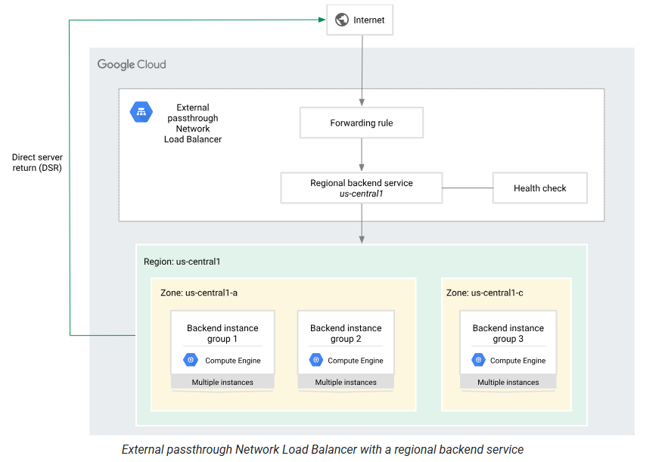
Target pool-based external passthrough Network Load Balancer: A target pool is the legacy backend supported with external passthrough Network Load Balancers. A target pool defines a group of instances that should receive incoming traffic from the load balancer.
Target pool-based load balancers support either TCP or UDP traffic. Forwarding rules for target pool-based external passthrough Network Load Balancers only support external IPv4 addresses.
Depending on the forwarding rule configuration, each target-pool based load balancer supports one of the following types of protocol traffic:
- TCP
- UDP
- TCP and UDP
The scope of the load balancer is regional, not global. This means that all backend instances for an external passthrough Network Load Balancer must be located in the same region. You can place backends in any zone of the region.
External passthrough Network Load Balancers support any and all ports. You can use an external passthrough Network Load Balancer to load balance either TCP or UDP traffic. Because the load balancer is a pass-through load balancer, your backends terminate the load-balanced TCP connection or UDP packets themselves.
If you are building applications in GKE, we recommend that you use the built-in GKE Service controller, which deploys Google Cloud load balancers on behalf of GKE users. This is the same as the standalone load balancing architecture, except that its lifecycle is fully automated and controlled by GKE.
2) Internal passthrough Network Load Balancers: Internal passthrough Network Load Balancers are built on the Andromeda network virtualization stack. An internal passthrough Network Load Balancer lets you to load balance TCP/UDP traffic behind an internal load-balancing IP address that is accessible only to systems in the same VPC network or systems connected to your VPC network. This load balancer can only be configured in Premium Tier. Internal passthrough Network Load Balancers distribute traffic among internal virtual machine (VM) instances in the same region in a Virtual Private Cloud (VPC) network. Unlike a proxy load balancer, an internal passthrough Network Load Balancer doesn't terminate connections from clients and then open new connections to backends. Instead, an internal passthrough Network Load Balancer routes connections directly from clients to the healthy backends, without any interruption. Responses from the healthy backend VMs go directly to the clients, not back through the load balancer. TCP responses use direct server return.
They support only regional backends so that you can autoscale across a region, protecting your service from zonal failures.
Use an internal passthrough Network Load Balancer in the following circumstances:
- You need a high-performance, pass-through Layer 4 load balancer for TCP, UDP, ICMP, ICMPv6, SCTP, ESP, AH, and GRE protocols.
- If serving traffic through TLS (SSL), it is acceptable to have SSL traffic terminated by your backends instead of by the load balancer. The internal passthrough Network Load Balancer cannot terminate SSL traffic.
- You need to forward the original packets unproxied. For example, if you need the client source IP address to be preserved.
- You have an existing setup that uses a pass-through load balancer, and you want to migrate it without changes.
You can access an internal passthrough Network Load Balancer in your VPC network from a connected network by using the following:
- VPC Network Peering
- Cloud VPN and Cloud Interconnect

Backend services:
A backend service defines how Cloud Load Balancing distributes traffic. A backend service distributes requests to healthy backends. The backend service configuration contains a set of values, such as the protocol used to connect to backends, various distribution and session settings, health checks, and timeouts. These settings provide fine-grained control over how your load balancer behaves. A backend service is either global or regional in scope.
Load balancers, Envoy proxies, and proxyless gRPC clients use the configuration information in the backend service resource to do the following:
- Direct traffic to the correct backends, which are instance groups or network endpoint groups (NEGs).
- Distribute traffic according to a balancing mode, which is a setting for each backend.
- Determine which health check is monitoring the health of the backends.
- Specify session affinity.
- Determine whether other services are enabled, including the following services that are only available for certain load balancers:
- Cloud CDN
- Google Cloud Armor security policies
- Identity-Aware Proxy
- Designate regional backend services as a service in App Hub applications.
If you're using either the global external Application Load Balancer or the classic Application Load Balancer, and your backends serve static content, consider using backend buckets instead of backend services.
Session affinity: Session affinity in load balancing means directing a user's requests to the same server throughout their session. This helps maintain consistent user experience, especially for applications that store user data temporarily on the server, like shopping carts in online stores. Without session affinity, each new request might go to a different server, causing potential issues or data loss. When you enable session affinity, your load balancer directs all requests from a particular end user to a specific endpoint.
Session affinity, also known as sticky sessions, is a system design strategy used in load balancing to ensure that all requests from a specific user during a session are directed to the same server. This approach is vital for web applications that store user-specific session data locally on the server, such as shopping carts, user profiles, or login states.
Session affinity lets you control how the load balancer selects backends for new connections in a predictable way as long as the number of healthy backends remains constant. This is useful for applications that need multiple requests from a given user to be directed to the same backend or endpoint.

Backend:
A backend is one or more endpoints that receive traffic from a Google Cloud load balancer, a Cloud Service Mesh-configured Envoy proxy, or a proxyless gRPC client. There are several types of backends:
- Instance group containing virtual machine (VM) instances. An instance group can be a managed instance group (MIG), with or without autoscaling, or it can be an unmanaged instance group. More than one backend service can reference an instance group, but all backend services that reference the instance group must use the same balancing mode.
- Zonal NEG
- Serverless NEG
- Private Service Connect NEG
- Internet NEG
- Hybrid connectivity NEG
- Port mapping NEG
- Service Directory service bindings
You cannot delete a backend instance group or NEG that is associated with a backend service. Before you delete an instance group or NEG, you must first remove it as a backend from all backend services that reference it.

Backend service versus Backend
Backend Service
- A logical configuration object in GCP Load Balancing
- Defines how traffic is distributed:
  - Load balancing policy (e.g., ROUND_ROBIN)
  - Health checks
  - Session affinity
  - Timeouts
  - Failover settings
- Can have multiple backends
Backend
- An individual resource (like a regional Managed Instance Group, a NEG, or zonal VMs) that handles traffic
- Each backend is assigned:
  - Location (region/zone)
  - Capacity weight (for traffic split)
  - Failover flag
  - Must match the protocol and port of the backend service

✅ Summary Table
Term Description
Backend Service Logical LB component that manages traffic distribution rules
Backend A compute resource (MIG/NEG/VM) attached to a backend service

Backend VMs and external IP addresses:
Backend VMs in backend services don't need external IP addresses:
For global external Application Load Balancers and external proxy Network Load Balancers: Clients communicate with a Google Front End (GFE) which hosts your load balancer's external IP address. GFEs communicate with backend VMs or endpoints by sending packets to an internal address created by joining an identifier for the backend's VPC network with the internal IPv4 address of the backend. Communication between GFEs and backend VMs or endpoints is facilitated through special routes.
For regional external Application Load Balancers: Clients communicate with an Envoy proxy which hosts your load balancer's external IP address. Envoy proxies communicate with backend VMs or endpoints by sending packets to an internal address created by joining an identifier for the backend's VPC network with the internal IPv4 address of the backend.
For external passthrough Network Load Balancers: Clients communicate directly with backends by way of Google's Maglev pass-through load balancing infrastructure. Packets are routed and delivered to backends with the original source and destination IP addresses preserved. Backends respond to clients using direct server return. The methods used to select a backend and to track connections are configurable.
Forwarding rules:
A forwarding rule specifies how to route network traffic to the backend services of a load balancer. A forwarding rule includes an IP address, an IP protocol, and one or more ports on which the load balancer accepts traffic. Some Google Cloud load balancers limit you to a predefined set of ports, and others let you specify arbitrary ports.

A forwarding rule and its corresponding IP address represent the frontend configuration of a Google Cloud load balancer.
Depending on the load balancer type, the following is true:
- Forwarding rules specify either a backend service, target proxy, or target pool.
- Forwarding rules and their IP addresses are either internal or external.
- Forwarding rules are either global or regional, depending on the load balancer and its network tier.
1) Internal forwarding rules
Internal forwarding rules forward traffic that originates inside a Google Cloud network. The clients can be in the same Virtual Private Cloud (VPC) network as the backends, or the clients can be in a connected network.
Internal forwarding rules are used by the following Google Cloud load balancers:
- Internal Application Load Balancer
- Internal proxy Network Load Balancer
- Internal passthrough Network Load Balancer
For an on-premises network connected through Cloud VPN or Cloud Interconnect, use an internal forwarding rule with an internal passthrough Network Load Balancer or internal Application Load Balancer.
Internal Application Load Balancer
The internal Application Load Balancer supports IPv4 traffic using either the HTTP, HTTPS, or HTTP/2 protocols.
The scope of the forwarding rule depends on the type of load balancer:
- Each regional internal Application Load Balancer has at least one regional internal forwarding rule. The regional internal forwarding rule points to the load balancer's regional target HTTP or HTTPS proxy. The forwarding rule is associated with a regional internal IP address.
- Each cross-region internal Application Load Balancer has at least one global internal forwarding rule. The global internal forwarding rule points to the load balancer's global target HTTP or HTTPS proxy. The global forwarding rule is configured with a regional internal IP address and associated with a regional subnet; whereas, a global external Application Load Balancer has a global forwarding rule that has a global anycast IP address.
Internal proxy Network Load Balancer
With an internal proxy Network Load Balancer, the supported traffic type is IPv4, and the supported protocol is TCP.
The scope of the forwarding rule depends on the type of load balancer:
- Each regional internal proxy Network Load Balancer has at least one regional internal forwarding rule. The forwarding rule specifies an internal IP address, port, and regional target TCP proxy. Clients use the IP address and port to connect to the load balancer's Envoy proxies—the forwarding rule's IP address is the IP address of the load balancer (sometimes called a virtual IP address or VIP).
- Each cross-region internal proxy Network Load Balancer has at least one global internal forwarding rule. The global internal forwarding rule points to the load balancer's global target TCP proxy. The global forwarding rule is configured with a regional internal IP address and associated with a regional subnet.
Internal passthrough Network Load Balancer
With an internal passthrough Network Load Balancer, the supported traffic types are either IPv4 or IPv6. Each internal passthrough Network Load Balancer has at least one regional internal forwarding rule. The regional internal forwarding rules point to the load balancer's regional internal backend service.
2) External forwarding rules
External forwarding rules accept traffic from client systems that have internet access, including:
- A client outside of Google Cloud
- A Google Cloud VM with an external IP address
- A Google Cloud VM without an external IP address using Cloud NAT or an instance-based NAT system
External forwarding rules are used by the following Google Cloud load balancer types:
- External Application Load Balancer
- External proxy Network Load Balancer
- External passthrough Network Load Balancer
External Application Load Balancer
For external Application Load Balancers, the forwarding rule and IP address depend on the load balancer mode, and the Network Service Tiers that you select for the load balancer.
In an external Application Load Balancer, a forwarding rule points to a target HTTP(S) proxy.
- The global external Application Load Balancer supports only Premium Tier.
- Each classic Application Load Balancer can be Premium Tier or Standard Tier.
- The regional external Application Load Balancer supports both Premium and Standard Tier.
IP address and forwarding rule requirements change depending on the Network Service Tier:
- In Premium Tier, global external Application Load Balancers and classic Application Load Balancers use a global external IP address, which can be either IPv4 or IPv6, and a global external forwarding rule. You can provide a globally accessible application that directs end users to backends in the closest region and distributes traffic among multiple regions.
- In Premium Tier, regional external Application Load Balancers use a regional external IPv4 address and a regional external forwarding rule.
- In Standard Tier, regional external Application Load Balancers and classic Application Load Balancers use a regional external IPv4 address and a regional external forwarding rule. A load balancer in Standard Tier can only distribute traffic to backends within a single region.
External proxy Network Load Balancer
An external proxy Network Load Balancer offers TCP proxying capability, with optional SSL offload. An external proxy Network Load Balancer is similar to an external Application Load Balancer because it can terminate SSL (TLS) sessions. However, these load balancers don't support path-based redirection like external Application Load Balancers
The forwarding rule and IP address depend on the type of load balancer mode and the Network Service Tiers that you select for the load balancer:
- The classic proxy Network Load Balancer can be Premium Tier or Standard Tier.
- The global external proxy Network Load Balancer supports only Premium Tier.
- The regional external proxy Network Load Balancer supports both Premium and Standard Tier.
IP address and forwarding rule requirements change depending on the Network Service Tier:
- In Premium Tier, global external proxy Network Load Balancers and classic proxy Network Load Balancers use a global external IP address, which can be either IPv4 or IPv6, and a global external forwarding rule. You can provide a globally accessible application that directs end users to backends in the closest region and distributes traffic among multiple regions.
- In Premium Tier, regional external proxy Network Load Balancers use a regional external IPv4 address and a regional external forwarding rule.
- In Standard Tier, regional external proxy Network Load Balancers and classic proxy Network Load Balancers use a regional external IPv4 address and a regional external forwarding rule. A load balancer in Standard Tier can only distribute traffic to backends within a single region.

External passthrough Network Load Balancer
External passthrough Network Load Balancers is a pass-through load balancer that distributes traffic among backend instances in a single region. An external passthrough Network Load Balancer uses a regional external forwarding rule and a regional external IP address. The regional external IP address can be accessed from anywhere on the internet and by Google Cloud VMs with internet access.
For backend service-based external passthrough Network Load Balancers, the regional external forwarding rule points to a backend service. Backend service-based external passthrough Network Load Balancers support TCP, UDP, ESP, GRE, ICMP, and ICMPv6 traffic. Forwarding rules for backend service-based load balancers can be configured with either IPv4 or IPv6 addresses. Forwarding rules for backend service-based external passthrough Network Load Balancers support the following advanced features:
- Direct traffic coming from a specific range of source IP addresses to a specific backend service. For more information, see Traffic steering.
- Distribute traffic across the load balancer's backend instances based on the weights reported by an HTTP health check using Weighted load balancing.
For target pool-based external passthrough Network Load Balancers, the forwarding rule points to a target pool. A target pool-based external passthrough Network Load Balancer supports only TCP or UDP traffic. Forwarding rules for target pool-based external passthrough Network Load Balancer support only IPv4 addresses.

Load balancing aspects:
To decide which load balancer best suits your implementation of Google Cloud, consider the following aspects of Cloud Load Balancing:
- Traffic type
- External versus internal load balancing
- Global versus regional load balancing
- Premium versus Standard Network Service Tiers
- Proxy versus Passthrough load balancing

1) Traffic type: The type of traffic that you need your load balancer to handle is another factor in determining which load balancer to use. You can pick a load balancer depending on the needs of your application and the type of traffic that it needs to handle.
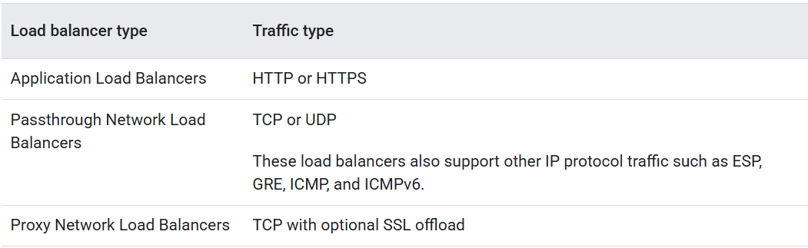
External versus internal load balancing
Google Cloud load balancers can be deployed as external or internal load balancers:
- External load balancers distribute traffic that comes from the internet to your Google Cloud Virtual Private Cloud (VPC) network.
- Internal load balancers distribute traffic that comes from clients in the same VPC network as the load balancer or clients connected to your VPC network by using VPC Network Peering, Cloud VPN, or Cloud Interconnect.
Global versus regional load balancing
Depending on the type of traffic you need the load balancer to handle, and whether your clients are internal or external, you might have the option to choose between either a global load balancer or a regional load balancer.
- Choose a global load balancer or cross-region load balancer when you want the load balancer to be distributed globally or span multiple regions. Such load balancers can also distribute traffic to backends across multiple regions, making them suitable when your application or content is distributed across multiple regions, or when you want the flexibility to add multi-region backends as your application grows to new geographies.
Only external load balancers are available as global load balancers. For internal load balancers with backends in multiple regions, choose the cross-region load balancer. Cross-region load balancers provide access by using a regional internal IP address that comes from the regional subnet in the VPC network. This is different from global load balancers, which provide access by using a single anycast IP address and by providing IPv6 termination at the load balancer. Review the following table to learn more.

- Choose a regional load balancer when you need backends in one region only, you require only IPv4 termination (not IPv6), or when you have jurisdictional compliance requirements for traffic to stay in a particular region.
Workloads that require regionalized resources for compliance reasons mandate that certain resources must be kept in a specific region, or require traffic to be terminated in a given region. If you require geographic control over where TLS is terminated, you should use a regional load balancer. A regional load balancer is deployed in a specific region that you choose and can connect to backends in the same region only. Thus, regional load balancers guarantee that you terminate TLS only in the region in which you've deployed your load balancer and its backends. Global load balancers terminate Transport Layer Security (TLS) in locations that are distributed globally, so as to minimize latency between clients and the load balancer.
Load balancers are a critical component of most highly available applications. It is important to understand that the resilience of your overall application depends not just on the scope of the load balancer you choose (global or regional), but also on the redundancy of your backend services.
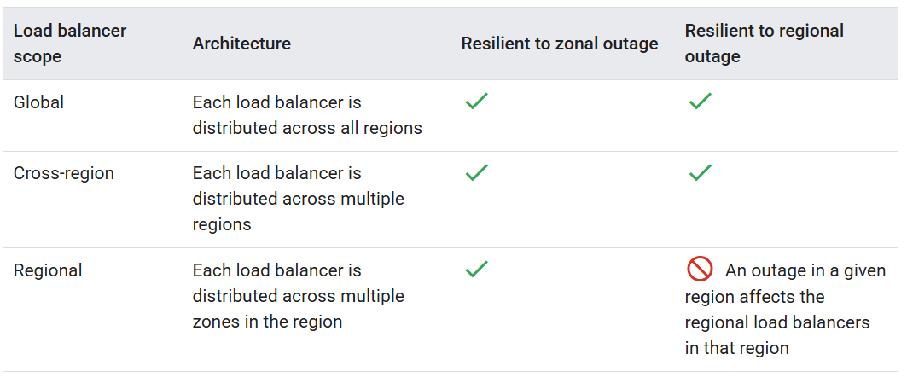
Proxy versus passthrough load balancing
Depending on the type of traffic you need the load balancer to handle, and whether your clients are internal or external, you might have the option to choose between either a proxy load balancer or a passthrough load balancer.
- Proxy load balancers terminate incoming client connections at the load balancer and then open new connections from the load balancer to the backends. All the Application Load Balancers and the proxy Network Load Balancers work this way. They terminate client connections by using either Google Front Ends (GFEs) or Envoy proxies.
- Passthrough load balancers don't terminate client connections. Instead, load-balanced packets are received by backend VMs with the packet's source, destination, and, if applicable, port information unchanged. Connections are then terminated by the backend VMs. Responses from the backend VMs go directly to the clients, not back through the load balancer. The term for this is direct server return. Use a passthrough load balancer when you need to preserve the client packet information. As the name suggests, the passthrough Network Load Balancers come under this category.
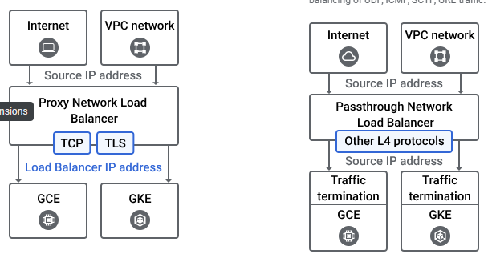
Premium versus Standard Network Service Tiers
Network Service Tiers lets you optimize connectivity between systems on the internet and your Google Cloud instances. Premium Tier delivers traffic on Google's premium backbone, while Standard Tier uses regular ISP networks. As a general rule, you'd choose Premium Tier for high performance and low latency. You can choose Standard Tier as a low-cost alternative for applications that don't have strict requirements for latency or performance.
- Premium Tier. If the IP address of the load balancer is in the Premium Tier, the traffic traverses Google's high‑quality global backbone with the intent that packets enter and exit a Google edge peering point as close as possible to the client.
If you don't specify a network tier, your load balancer defaults to using the Premium Tier. Certain external load balancers, such as the global external Application Load Balancer and the global external proxy Network Load Balancer can only be configured in Premium Tier.
All the internal load balancers always use Google's high-quality global backbone and are therefore always configured to be Premium Tier by default. However, the Internet egress charges associated with Premium Tier don't apply to internal load balancer traffic.
- Standard Tier. If the IP address of the load balancer is in the Standard Tier, the traffic enters and exits the Google network at a peering point closest to the Google Cloud region where the load balancer is configured.
As noted in the summary table, not all load balancers can be deployed in the Standard Tier, so plan your budget accordingly.
Because you choose a tier at the resource level—such as the external IP address for a load balancer or VM—you can use Standard Tier for some resources and Premium Tier for others. You can use the decision tree in the Network Service Tiers documentation to help you make your decision.

Summary of Google Cloud load balancers
The following table provides details, such as the network service tier on which each load balancer operates, along with its load balancing scheme.
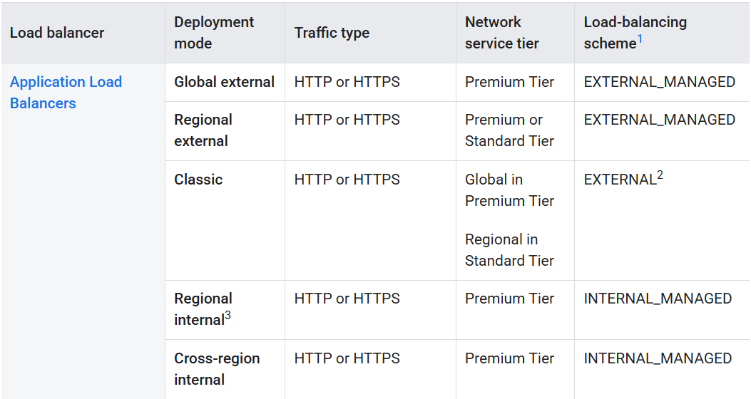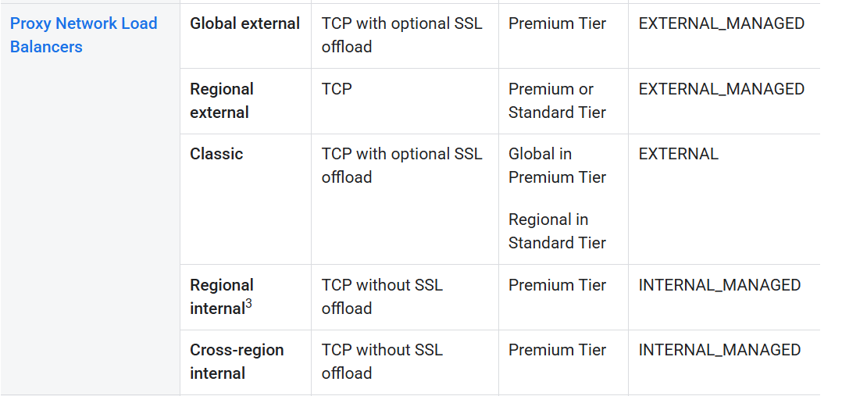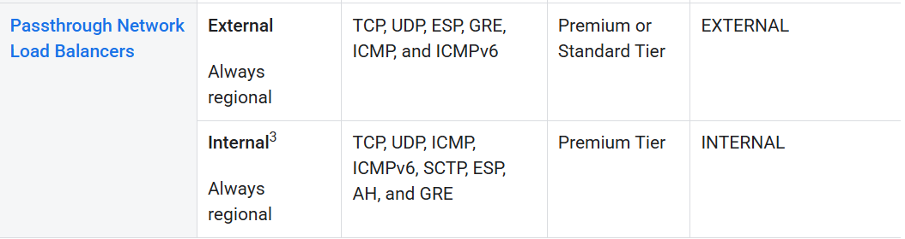

Three-tier web services
You can deploy a combination of Application Load Balancers and Network Load Balancers to support conventional three-tier web services. The following example shows how you can deploy each tier, depending on your traffic type:
- Web tier. The application's frontend is served by an external Application Load Balancer with instance group backends. Traffic enters from the internet and is proxied from the load balancer to a set of instance group backends in various regions. These backends send HTTP(S) traffic to a set of internal Application Load Balancers.
- Application tier. The application's middleware is deployed and scaled by using an internal Application Load Balancer and instance group backends. The load balancers distribute the traffic to middleware instance groups. These middleware instance groups then send the traffic to internal passthrough Network Load Balancers.
- Database tier. The Network Load Balancers serve as frontends for the database tier. They distribute traffic to data storage backends in various regions.
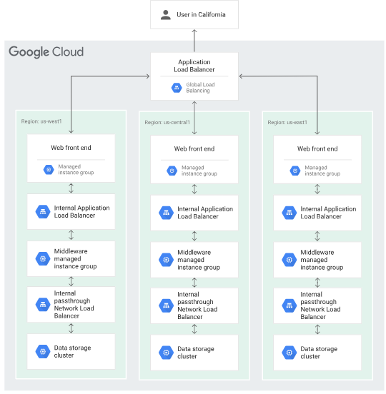
Application Load Balancer Vs Network Load Balancer
- NLBs work at the transport layer (Layer 4), focusing on TCP and UDP traffic based on IP addresses and ports, offering high performance and low latency. ALBs, on the other hand, operate at the application layer (Layer 7), inspecting HTTP/HTTPS traffic and routing requests based on content, such as URLs and headers.
- NLB just forward requests whereas ALB examines the contents of the HTTP request header to determine where to route the request. So, an ALB supports advanced request (content-based) routing.
- ALB doesn’t provide support for static IP addresses whereas NLB provides support for zonal static IP addresses
- Network load balancing cannot assure availability of the application, where as Application load balancing can.
- NLB is ideal for scenarios where high performance and low latency are paramount, while ALB is suitable for applications that require more sophisticated routing and content-based decisions.
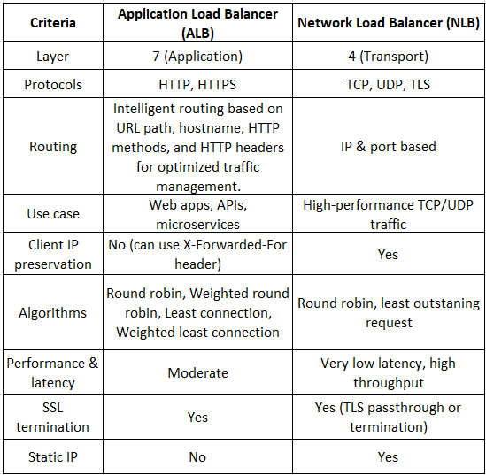
Cloud CDN (Content Delivery Network)
Cloud CDN (Content Delivery Network) uses Google's global edge network to serve content closer to users, which accelerates your websites and applications.
A content delivery network (CDN) is a group of interconnected servers distributed around the world that accelerate the delivery of web content by serving it from locations closer to users. By storing copies of files — a process called caching — CDNs minimize the time it takes for content like web pages, images, and video to reach a user’s device. This prevents users from having to wait for content to load as they watch movies, download software, make purchases, or perform other tasks online. A cloud CDN is a CDN that uses distributed cloud-based compute, storage, and networking resources. Many cloud services providers offer CDNs as part of their platforms.
A content delivery network (CDN) is a geographically distributed group of servers that caches content close to end users. A CDN allows for the quick transfer of assets needed for loading Internet content, including HTML pages, JavaScript files, stylesheets, images, and videos.
The popularity of CDN services continues to grow, and today the majority of web traffic is served through CDNs, including traffic from major sites like Facebook, Netflix, and Amazon.
A properly configured CDN may also help protect websites against some common malicious attacks, such as Distributed Denial of Service (DDOS) attacks.
Cloud CDN works with the global external Application Load Balancer or the classic Application Load Balancer to deliver content to your users. The external Application Load Balancer provides the frontend IP addresses and ports that receive requests and the backends that respond to the requests.
Cloud CDN content can be sourced from various types of backends.
In Cloud CDN, these backends are also called origin servers. Figure 1 illustrates how responses from origin servers that run on virtual machine (VM) instances flow through an external Application Load Balancer before being delivered by Cloud CDN. In this situation, the Google Front End (GFE) comprises Cloud CDN and the external Application Load Balancer.
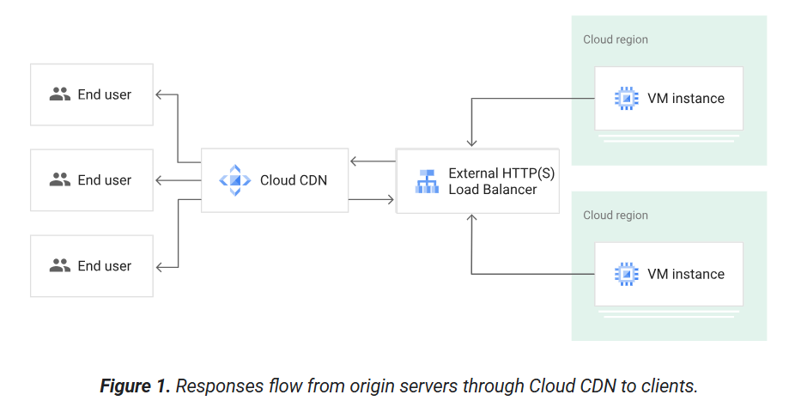
A Cloud CDN (Content Delivery Network) uses a global network of servers (Points of Presence or PoPs) to cache and deliver website content (like images, videos, JS, CSS) from locations physically closer to end-users, drastically reducing latency, speeding up load times, and reducing strain on original servers. Providers like Google Cloud, AWS CloudFront, and Cloudflare offer these services, leveraging their massive global networks to serve content efficiently and securely at scale, handling high traffic for apps, e-commerce, and media.
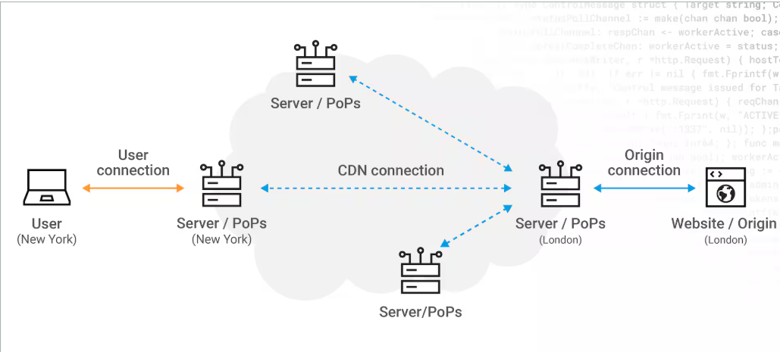

How does a CDN work?
The purpose of a cloud CDN is to minimize latency, which prevents the delay that users experience when they try to access a web page or streaming video. Even small delays can cause enormous frustration for users who have ever higher expectations about how quickly content should be loaded. To avoid this, CDNs cache content in servers located around the world, and route content requests from users to the server that can deliver it most quickly. When one server becomes congested, a CDN will route content around it to another server that can deliver it faster.
When a user requests content from an external Application Load Balancer, the request arrives at a GFE that is at the edge of Google's network as close as possible to the user.
If the load balancer's URL map routes traffic to a backend service or backend bucket that has Cloud CDN configured, the GFE uses Cloud CDN.
Cache hits and cache misses
A cache is a group of servers that stores and manages content so that future requests for that content can be served faster. The cached content is a copy of cacheable content that is stored on origin servers.
If the GFE looks in the Cloud CDN cache and finds a cached response to the user's request, the GFE sends the cached response to the user. This is called a cache hit. When a cache hit occurs, the GFE looks up the content by its cache key and responds directly to the user, shortening the round-trip time and saving the origin server from having to process the request.
A partial hit occurs when a request is served partially from cache and partially from a backend. This can happen if only part of the requested content is stored in a Cloud CDN cache, as described in Support for byte range requests.
The first time that a piece of content is requested, the GFE determines that it can't fulfill the request from the cache. This is called a cache miss. When a cache miss occurs, the GFE forwards the request to the external Application Load Balancer. The load balancer then forwards the request to one of your origin servers. When the cache receives the content, the GFE forwards the content to the user.
If the origin server's response to this request is cacheable, Cloud CDN stores the response in the Cloud CDN cache for future requests. Data transfer from a cache to a client is called cache egress. Data transfer to a cache is called cache fill.

Figure 2 shows a cache hit and a cache miss:
- Origin servers running on VM instances send HTTP(S) responses.
- The external Application Load Balancer distributes the responses to Cloud CDN.
- Cloud CDN delivers the responses to end users.
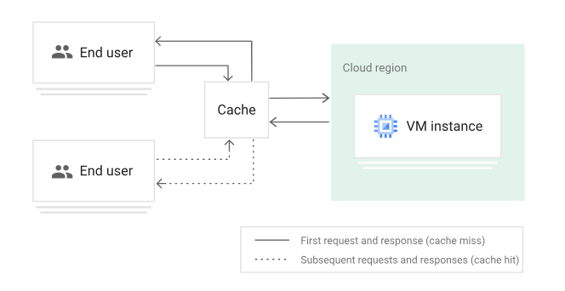
What are the components of a cloud CDN?
- Points of presence (PoPs) are data centers distributed around the world that serve content to nearby users. PoPs reduce the time required to serve content to a user’s device.
- Servers with large amounts of storage and RAM store and deliver cached files to users, accelerating the load times of websites and reducing bandwidth consumption.
- Cloud load balancing technology seamlessly directs traffic to the PoPs that can serve content to a user fastest, evenly distributing the load across cloud resources and achieving greater cloud optimization.
- Solid-state drives (SSD), hard disk drives (HDD), and random-access memory (RAM) within cloud CDN servers store files to be served, with the most requested files being stored on the fastest media.
How does a CDN improve online experiences?
Many online experiences rely on dynamic web content that can change with every user request. Caching static copies of this content is impossible. To accelerate response times, CDNs can forward the request to the original server through a trusted, established connection that elicits a faster response.
What are the benefits of a CDN?
- High performance. CDNs improve the performance of web content, high-quality video, audio streams, software downloads, and other online experiences.
- Greater availability. Superior cloud CDNs can absorb massive amounts of traffic from users while still serving content at an optimal rate.
- Better security. Distributed denial-of-service (DDoS) attacks and web-based exploits not only threaten organizations but the online experience for users as well. CDN systems have made DDoS protection and cloud-based security a core competency, providing cloud-based security solutions to protect content providers and users by mitigating a wide array of attacks that could compromise delivery and availability.
- Lower cost. Serving content from traditional clouds can incur significant data egress charges. CDNs reduce cost by reducing bandwidth consumption and the significant expense associated with purchasing bandwidth.
What are the use cases of the cloud CDN?
- Delivering content at high speeds. Using a cloud CDN, content providers and media companies can deliver content to users much more quickly, providing high-quality, low-latency online experiences.
- Improving the quality of streaming media. Companies that deliver audio and video streaming rely on CDNs to reduce delivery time, minimize bandwidth costs, and scale up to meet user demand as needed. Streaming video services especially benefit from cloud CDN technology that enables them to meet spikes in demand when certain video content becomes quite popular.
- Scaling up for multiple users. From gaming companies to SaaS and business productivity platforms, the scalability of CDNs enable millions of users to access a website or platform simultaneously without experiencing degraded performance.
Who uses a CDN?
CDNs are increasingly the backbone of the internet’s best applications. Websites and web applications delivered through cloud CDNs enable faster page loads and improve online experiences. Content owners such as ecommerce sites, media properties, and cloud computing companies rely on CDNs to improve customer experiences, reduce abandonment rates, enhance conversion rates, and build greater customer loyalty. For network service providers that offer video streaming and rich media services, CDNs help reduce subscriber churn, minimize traffic on the core network, and enable operators to sell services to enterprises and third-party content owners.

SSL/TLS certificates (standard protocol for secure communications on the Internet)
SSL/TLS is the most widely used cryptographic protocol on the internet. Technically, TLS is the successor to SSL, although the terms are sometimes used interchangeably, as they are in this document.
Transport Layer Security (TLS) is used to encrypt information while it is sent over a network, providing privacy between a client and a server or load balancer. An Application Load Balancer or proxy Network Load Balancer that uses SSL requires at least one private key and SSL certificate.
Secure Sockets Layer (SSL) is an Internet security protocol that encrypts data to ensure secure communication between devices over a network. Originally developed by Netscape in 1995, SSL provides privacy, authentication and data integrity for online communications. SSL is the predecessor of TLS (Transport Layer Security), which is now the standard protocol for secure communications on the Internet.
SSL vs TLS
- SSL: Older protocol, no longer considered secure.
- TLS: Updated and more secure version of SSL.
- Despite TLS being the standard, the term "SSL" is still widely used in marketing and casual references.
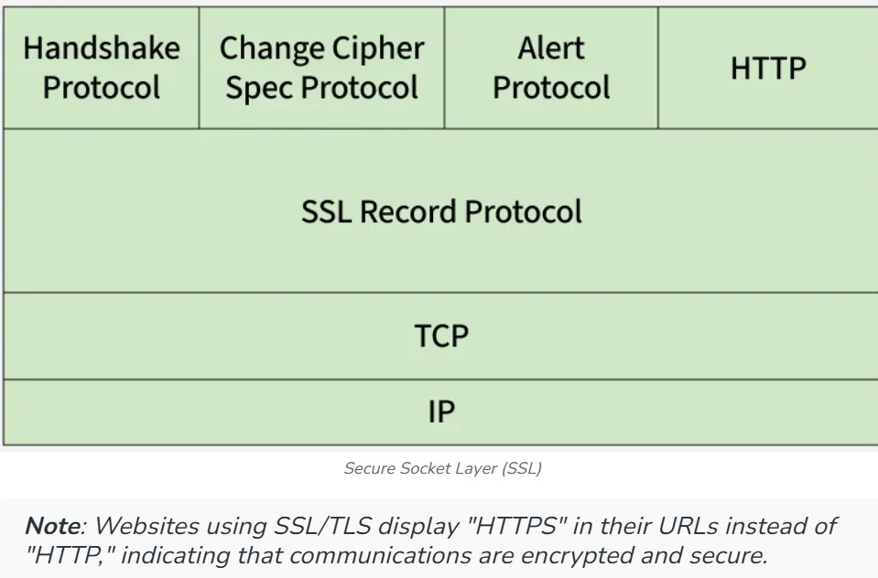

Certificate types
Google Cloud supports both self-managed and Google-managed certificates.
Self-managed SSL certificates
Self-managed SSL certificates are certificates that you obtain, provision, and renew yourself. Self-managed certificates can be any of these Public key certificate types:
- Domain Validation (DV)
- Organization Validation (OV)
- Extended Validation (EV) certificates
You can create self-managed SSL certificates using:
- Compute Engine SSL certificate resources: for more information, see Use self-managed SSL certificates.
- Certificate Manager: for more information, see Deployment overview in the Certificate Manager documentation.
Google-managed SSL certificates
Google-managed SSL certificates are certificates that Google Cloud obtains, manages, and renews automatically. Google-managed certificates are always Domain Validation (DV) certificates. They don't demonstrate the identity of an organization or individual associated with the certificate.
Google-managed certificates using wildcards are only supported by Certificate Manager when using DNS authorization.
You can create Google-managed SSL certificates using:
- Compute Engine SSL certificate resources: only global Compute Engine sslCertificates resources support Google-managed SSL certificates; regionSslCertificates don't support them. Global Compute Engine SSL certificates support only publicly trusted Google-managed certificates. For more information, see Use Google-managed SSL certificates.
- Certificate Manager: Certificate Manager certificates (both global and regional) support both publicly trusted Google-managed certificates and privately trusted Google-managed certificates. For more information, see Certificates in the Certificate Manager documentation.

A CSR (Certificate Signing Request) in SSL is an encoded file containing your public key and organization details (domain, company, location) sent to a Certificate Authority (CA) as a formal application to get an SSL/TLS certificate, proving you control the private key corresponding to the public key, which the CA then signs to issue your trusted certificate for encryption.
What a CSR does:
- Digital Application: It's your formal request to a CA (like DigiCert, SSL.com) to issue a certificate.
- Information Carrier: It carries essential details: domain name (Common Name), organization, location, etc..

Key components in a CSR:
- Common Name (CN): The fully qualified domain name (e.g., www.example.com).
- Organization (O): Your legal company name.
- Location: City, State/Province, Country.
- Public Key: The public part of your key pair, used for encryption.

How it works in the SSL process:
- Generate on Server: You create the CSR on the server where the certificate will be installed, generating a private key you keep secret.
- Submit to CA: You send the CSR to a Certificate Authority.
- CA Verification: The CA validates the information in the CSR.
- Certificate Issuance: If approved, the CA signs your public key (from the CSR) and sends back the SSL certificate, which you then install on your server.

Cloud NAT (Network Address Translation)
Cloud NAT is a high-performance, scalable, reliable Google Cloud-managed Network Address Translation service.
To use Cloud NAT, you’ll first create a NAT gateway. Then you’ll be able to configure the NAT policies to safeguard outbound internet connections to GCE and GKE workloads from external threats. You configure Cloud NAT by creating a Cloud NAT gateway in the region of the subnets that require NAT. The gateway then serves each subnet that you specify in its configuration. NAT is automatically applied to the resources that match your Cloud NAT configuration after you create a Cloud NAT gateway and configure it to serve the subnets where those resources run.
Network Address Translation (NAT) allows multiple devices in a private network to access the internet using a single public IP address. It helps conserve IPv4 addresses and hides internal systems for added security.
- Translates private IP addresses into public IP addresses and vice versa.
- Mitigates public IPv4 address depletion by allowing IP address sharing.
- Hides internal network addresses from external networks.
- Enables multiple devices to share a single public IP address using port mapping (PAT).

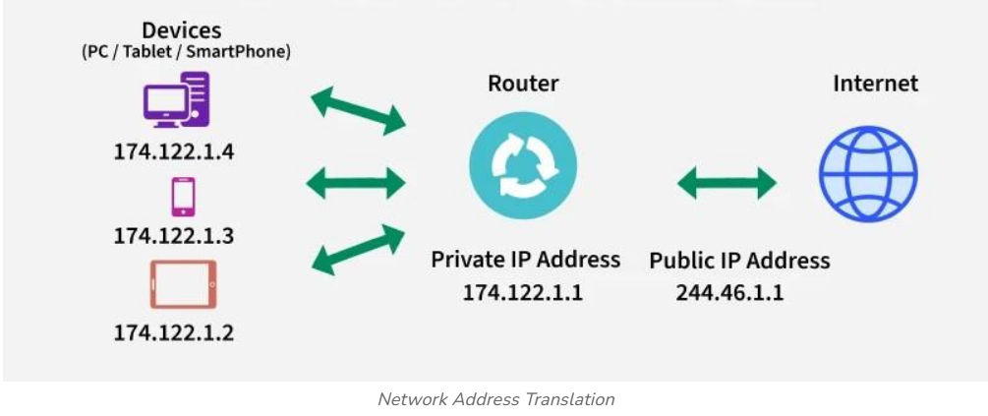
Network Address Translation (NAT) is a process that enables one, unique IP address to represent an entire group of computers. In network address translation, a network device, often a router or NAT firewall, assigns a computer or computers inside a private network a public address. In this way, network address translation allows the single device to act as an intermediary or agent between the local, private network and the public network that is the internet. NAT’s main purpose is to conserve the number of public IP addresses in use, for both security and economic goals.
Network Address Translation (NAT) is a networking technique that allows a router to map multiple private IP addresses from an internal network (like a home or office LAN) to a single public IP address for internet access. It acts as a bridge between internal and external networks, conserving public IPv4 addresses and enhancing security. Its primary use is to conserve limited IPv4 addresses, provide basic security by hiding internal network structure and enable seamless internet connectivity for multiple devices.
Network address translation (NAT) is a technique commonly used by internet service providers (ISPs) and organizations to enable multiple devices to share a single public IP address. By using NAT, devices on a private network can communicate with devices on a public network without the need for each device to have its own unique public IP address.

Main Uses of NAT:
- IP Address Conservation: NAT solves the limited availability of IPv4 addresses by allowing many devices to share one public IP address.
- Security: By hiding internal private IP addresses behind a single public address, NAT prevents external threats from directly accessing devices on the internal network. NAT acts as a basic firewall preventing direct, unsolicited externam connections to internal devices.
- Network Flexibility: It allows companies to use private IP addresses internally, simplifying network management.
- Load Balancing & Routing: NAT facilitates efficient traffic management and allows for sophisticated routing in large, complex, or multi-cloud network architectures.

